BUY PLAN
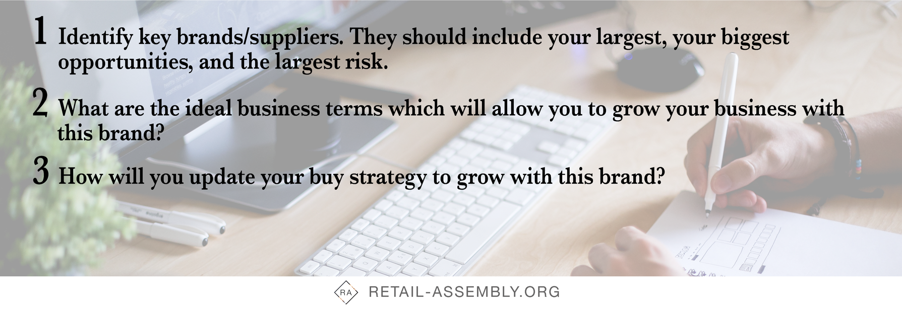

BUY PLAN for Brand x

Current Terms | Ideal Terms | Updated Terms
Payment terms

Discounting / mark-up

Volume agreements

Profit agreements

Etc.

Updated buying and assortment planning strategy:

BUY PLAN for Brand x

Current Terms | Ideal Terms | Updated Terms

Updated buying and assortment planning strategy:

BUY PLAN for Brand x

Current Terms | Ideal Terms | Updated Terms

Updated buying and assortment planning strategy:

BUY PLAN for Brand x

Current Terms | Ideal Terms | Updated Terms

Updated buying and assortment planning strategy:

